**PREDICTING THE ENERGY OUTPUT OF WIND TURBINE BASED ON WEATHER CONDITIONS WATSON AUTO AI**

**1. INTRODUCTION:**

**1.1. Overview:**

Predicting wind speed for wind energy conversion systems (WECS) is an essential monitor, control, plan, and dispatch generated power and meets customer needs. In this project, we propose the use of the artificial neural networks (ANNs) using IBM Watson Auto AI method as a means of predicting daily wind energy output in certain locations.The suggested model is a feed-forward neural network model with the administered learning technique using a back-propagation algorithm.We wish to show that even data that is publicly available for weather stations close to wind farms can be used to give a good prediction of the energy output.

**1.2. Purpose:**

Wind energy plays an increasing role in the supply of energy world-wide. The energy output of a wind farm is highly dependent on the wind conditions present at its site. If the output can be predicted more accurately, energy suppliers can coordinate the collaborative production of different energy sources more efficiently to avoid costly overproduction.

**2. LITERATURE SURVEY:**

**2.1. Existing Problem:**

Wind energy plays an increasing role in the supply of energy world-wide. The energy output of a wind farm is highly dependent on the weather conditions present at its site. If the output can be predicted more accurately, energy suppliers can coordinate the collaborative production of different energy sources more efficiently to avoid costly overproduction. In this paper, we predict energy prediction based on weather data and analyse the important parameters as well as their correlation on the energy output.

**2.2. Proposed Problem:**

Our aim is to map weather data to energy production. We wish to show that even data that is publicly available for weather stations close to wind farms can be used to give a good prediction of the energy output. Furthermore, we examine the impact of different weather conditions on the energy output of wind farms. We are building an IBM Watson AutoAI Machine Learning technique to predict the energy output of wind turbine. The model is deployed on IBM cloud to get scoring end point which can be used as API in mobile app or web app building. We are developing a web application which is built using node red service. We make use of the scoring end point to give user input values to the deployed model. The model prediction is then showcased on User Interface to predict the energy output of wind turbine.

**3. THEOROTICAL ANALYSIS:**

**3.1. Block Diagram:**

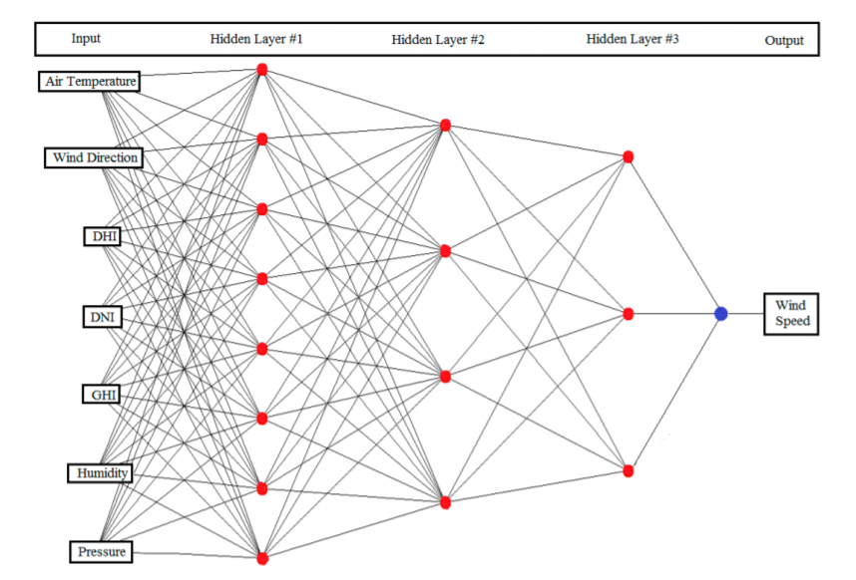

**3.2. Hardware / Software Designing:**

**3.2 HARDWARE/SOFTWARE REQUIRED**:

**IBM**: Acts as a platform for using various services like "NODE-RED" and also for displaying the values of open weather which come as outputs from the written python code.

**NODE-RED**: Software available within the IBM Platform and helps us in using the MIT app inventor and also has the UI option to display the data and required warnings/commands in the python. Nodes act as the backbone here.

**4. EXPERIMENT ANALYSIS:**

IBM is a platform which is used to create several services and software. It helps to store the data and retrieve it whenever required. Initially we have to create the Watson studio and then add the Auto AI experiment. Next, we have to upload the dataset and then choose the predicted output and then click on run experiment and then it will show the pipeline comparison, once it gets completed we have to save the best pipeline as model. Next process, we have to deploy our project and then give our input values to test our project. Finally, we have to create a node red and insert all the flows and include our scoring end point and API key to create a web page.

**5. FLOW CHART:**

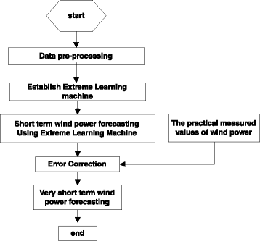

**6. RESULT:**

Hence, based on the input values we got the output values in both Watson studio and web application page. using the node red flow we created the web page.

**7. PROS AND CONS:**

**7.1. ADVANTAGES:**

* It's a clean fuel source.
* Wind energy doesn't pollute the air like power plants that rely on combustion of fossil fuels, such as coal or natural gas.
* Wind turbines don't produce atmospheric emissions that cause acid rain or greenhouse gasses.
* Wind energy is a domestic source of energy.

**7.2.DISADVANTAGES:**

* The Wind Fluctuates. Wind energy has a similar drawback to solar energy in that it is not constant.
* Wind turbines Are Expensive. Although costs are reducing, wind turbines are still very expensive.
* Wind Turbines Pose a Threat to Wildlife.
* Wind Turbines Are Noisy.
* Wind Turbines Create Visual Pollution.

**8. APPLICATIONS:**

* The wind energy is used to propel the sailboats in river and seas to transport men and materials from one place to another.
* Wind energy is used to run pumps to draw water from the grounds through wind mills.
* Wind energy has also been used to run flour mills to grind the grains like wheat and corn into flour.

**9. CONCLUSION:**

Wind energy is probably the solution for our energy demands. It has great potential and is easy to manage. All you have to do is build the turbine and everything else is going to be free. With only 1 turbine, you can power over 200 homes.  Every wind turbine lasts for about 20-25 years. As long as the wind blows, wind turbines can harness the wind to create power. Wind power only makes up a tiny percent of electricity that is produced. Unlike coal, wind turbines don't create greenhouse gases and are completely renewable source. Many people believe that the wind energy could soon be our main source of energy. Though wind turbines can cause complaints and fatalities of wildlife, it could be the energy solution we have been looking for.

**10. FUTURE SCOPE:**

Wind power development, which started in India in the 1990s, has significantly increased in the last few years. India plans to add 60 GW of wind power installed capacity by the year 2022. Although a relative newcomer to the wind industry as compared to Denmark or the US, domestic policy support for wind power has enabled India to become the fourth largest in the world with an installed capacity of over 34 GW as of June 2018. The total installed capacity of renewable power, which was 43 GW as on March 2016, had gone up to 57 GW as on March 2017. Of this, wind power alone accounted for 56% of renewable power capacity. India has a high potential for generation of renewable energy from various sources—wind, solar, biomass, small hydro and the co generation of basset. The total potential for renewable power generation in the country as on March 31, 2017, is estimated to be at 1001 GW which includes a solar potential of 650 GW, 302 GW of wind power potential at 100 m hub height, small hydro potential of 21 GW, biomass power of 18 GW, 7 GW from bagasse based co generation in sugar mills and 2.5 GW from waste to energy.

**11. BIBILIOGRAPHY:**

* https://www.kaggle.com/berkerisen/wind-turbine-scada-dataset/
* https://cloud.ibm.com/catalog/services/watson-studio/
* <https://emerj.com/ai-sector-overviews/ai-for-weather-forecasting/>

**APPENDIX**

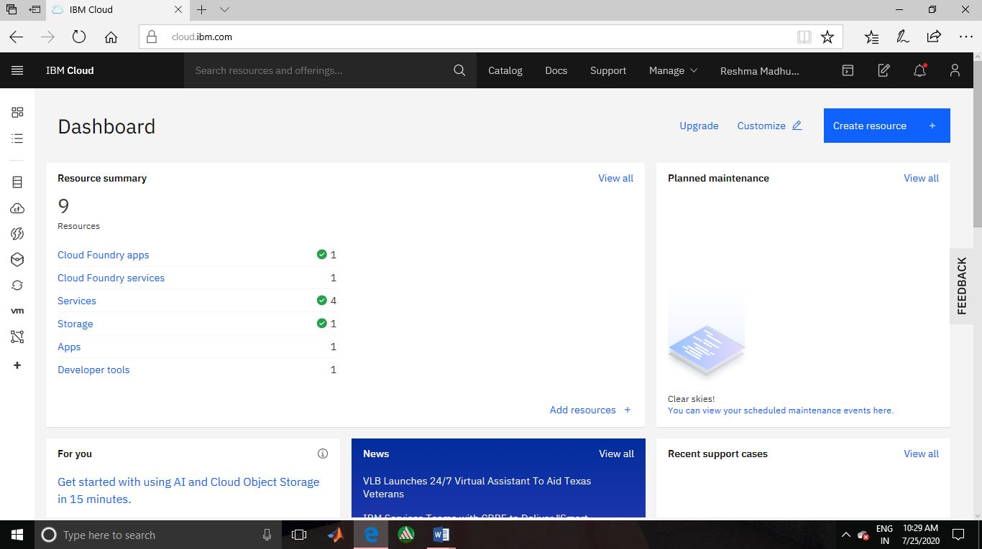

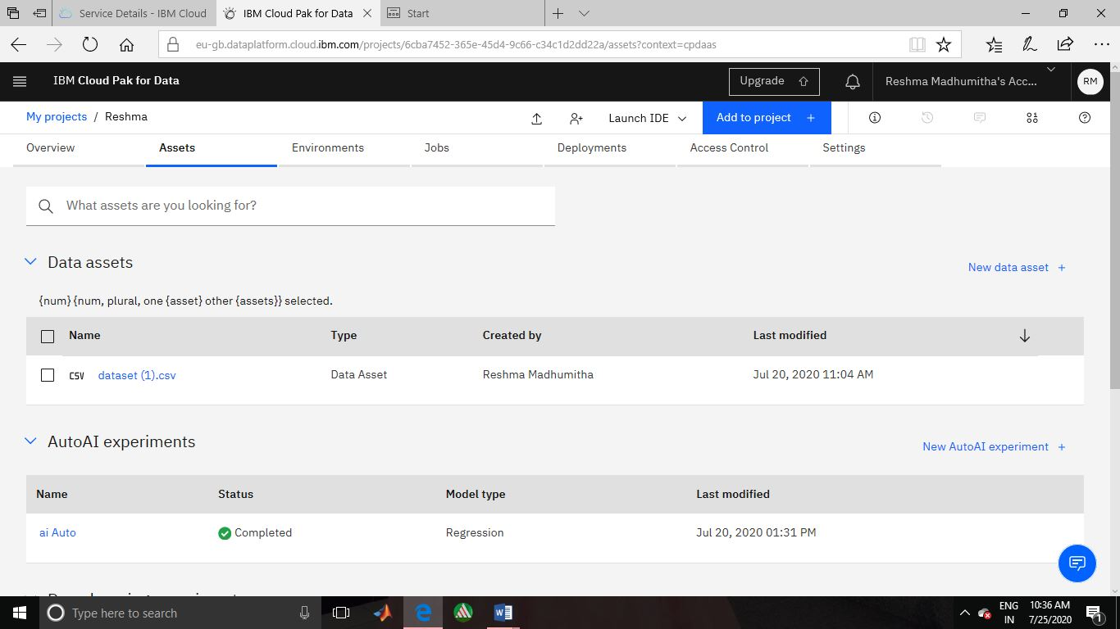

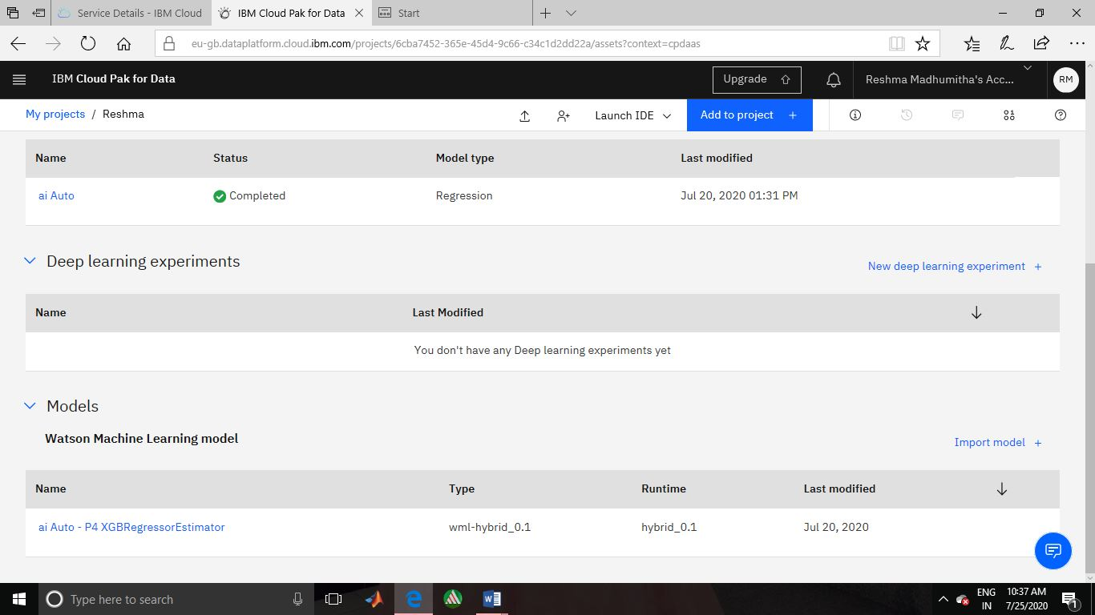

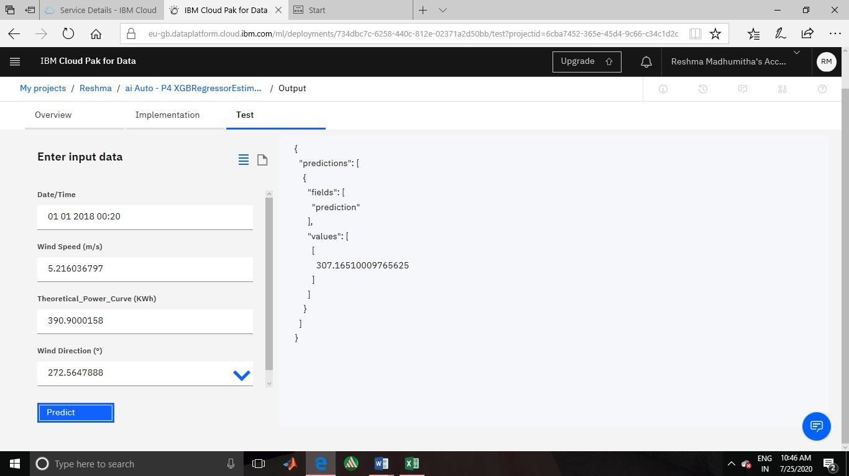

**13. NODERED FLOW:**

